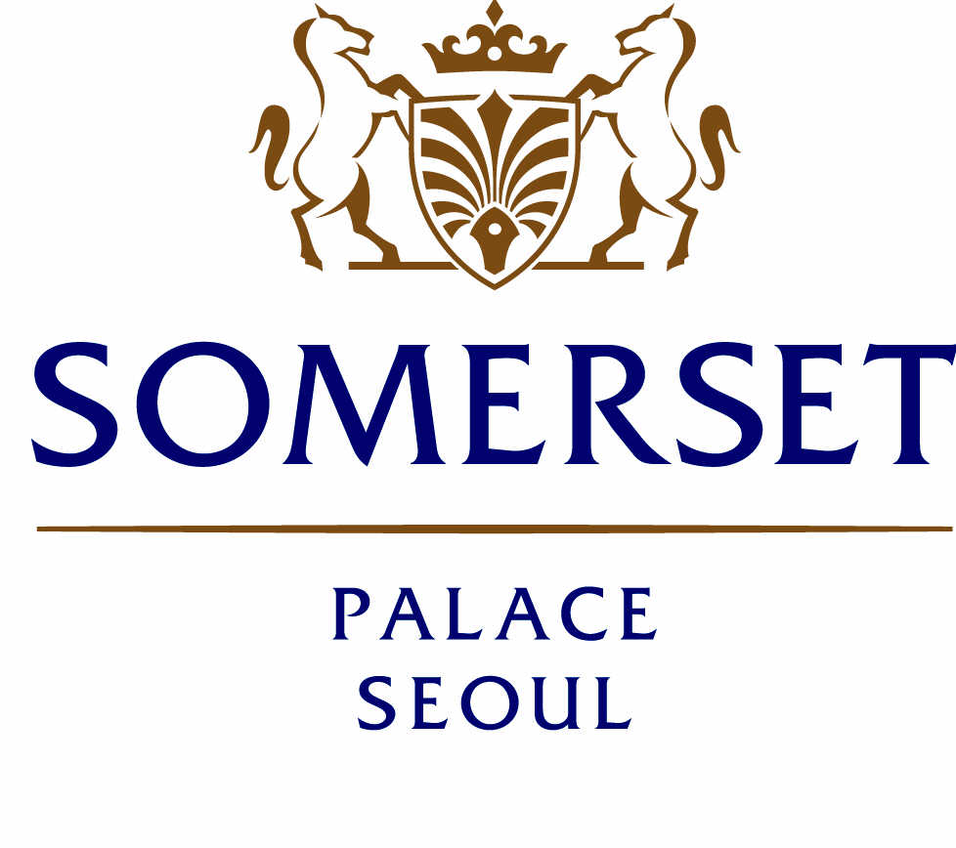
Location Information

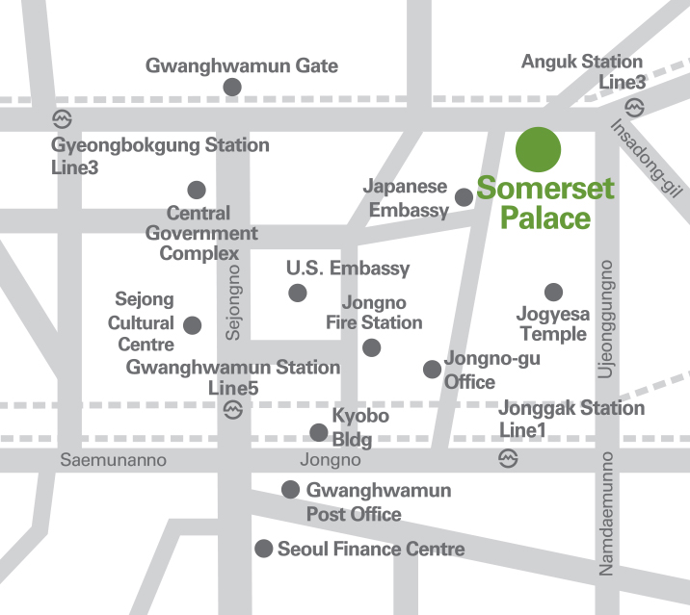

Somerset Palace Seoul

Telephone (82-2) 6730-8888
Facsimile (82-2) 6730-8080
Email enquiry.seoul@the-ascott.com
Website www.somerset.com
Address 7, Yulgok-ro 2-gil, Jongno-gu
Seoul 03143 South Korea

- From Subway Station:

- Jonggak Station (Line 1) Exit 2
- Anguk Station (Line 3) Exit 6
- Gwanghwamun Station (Line 5) Exit 2

- From Incheon International Airport: Airport Limousine Bus No. 6011

- Fare is KRW 10,000 per one way

Terminal 1 : 1st Floor No. 5B
: Asiana Airlines, low-cost airlines and other foreign airlines

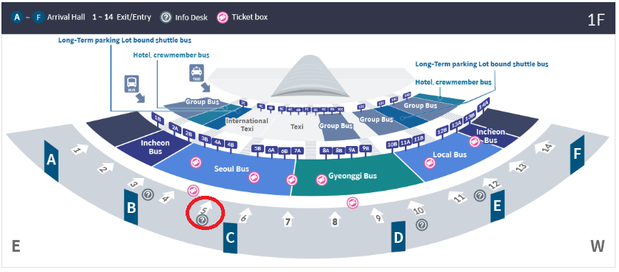
* Bus ticket office : You can purchase bus tickets and get information at ticketing offices next to Exit 4 and 9 in Arrival Hall Floor 1 (indoors) or offices next to Exit 4, 6, 7, 8, 11, 13, and 9C (outdoors).

Terminal 2 : Traffic center Basement 1 No. 31
: Korean Air, Delta Air Lines, Air France and KLM Royal Dutch Airlines, AeroMexico, Alitalia, China Airlines, Garuda Indonesia Airways, Czechoslovak State Airlines, Xiamen Airlines, Aeroflot Russian Airlines

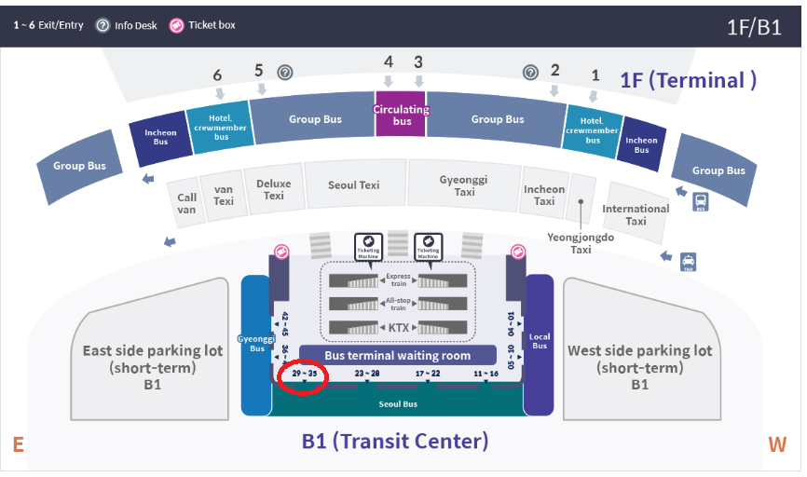
* Bus ticket office : You can purchase bus tickets and get information at ticketing offices outdoors and inddors on Transit Center (B1).

- Bus Route : 6011 (Incheon International Airport ↔ Induk Univ.)

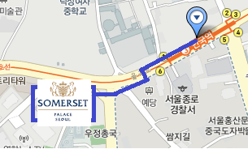
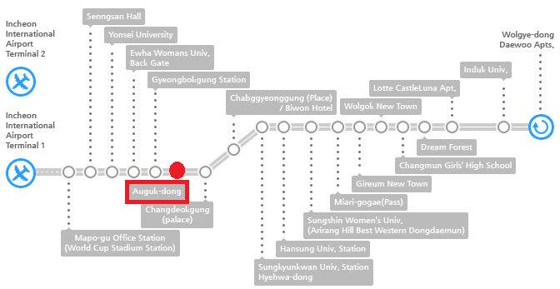
The limousine bus runs every 20 ~ 30 minutes from Incheon International Airport
and it will take approximately 70 minutes to Anguk-dong (Anguk Station) stop.
(3 minutes’ walk to Somerset Palace Seoul)

For more information, please visit http://www.somerset.com/korea-south/seoul/somerset-palace-seoul/index.html

For our interactive map information, please visit
http://www.somerset.com/korea-south/seoul/somerset-palace-seoul/location/index.html

